

Navigating Google Search and Translate

A Digital Literacy Documentation

Code for Nepal

10/8/20

Table of Contents

1. Introduction 3

2. Overview 4

2.1 Instruction Format and Expectations 4

3. User Access Considerations 5

4. Using Google translate 6

4.1 Navigating Google Translate 6

5. Using Google Search 8

5.1 Navigating Google Search Results 8

6. Using Google Scholar 10

6.1 Navigating Google Scholar Search Results 11

6.2 Saving to ‘My Library’ 11

6.3 Viewing ‘My Library’ 12

Figure 1: Downloading Google Chrome 5

Figure 2: Navigating to Google Translate 6

Figure 3: Google Translate web page 6

Figure 4: Navigating Google Translate 6

Figure 5: Selecting a Language in Google Translate 7

Figure 6: Volume Icon for Google Translate 7

Figure 7: Google Search Home Page 8

Figure 8: Navigating Google Search 8

Figure 9: Google Scholar Home Page 10

Figure 10: Navigating Google Scholar 11

Figure 11: Saving to Library part 1 11

Figure 12: Saving to Library Part 2 12

Figure 13: Navigating to 'My Library' 12

Figure 14: Navigating 'My Library' 12

# Introduction

This user documentation will provide the necessary information to make the best use of several of Google’s features. It will cover the usage of Google Translate, Google Search, and Google Scholar. Google is a large company that offers a wide variety of technical services and compilations of data. They provide extensive resources to aid in the discovery of information dealing with all ranges of subjects, from history to math to agriculture. As a result, being able to effectively use the tools they provide allows for a wealth of knowledge to the users.

According to NepalMap, around 67.91% of Nepali are literate and only 39.3% have beyond primary level education. With the content of this documentation and by learning to better navigate Google, the digital literacy rate of Nepali can be increased greatly. These tools can be integrated into all levels of education as well as personal use.

# Overview

This documentation will provide instruction on how to use the following features of Google:

* Google Translate
* Google Search
* Advanced Google Search
* Google Scholar

## 2.1 Instruction Format and Expectations

This documentation will use pictures and step-by-step instructions to guide the reader through using the google tools. The reader of this will be referred to as “user” in the from now on.

Each action the user will need to take will be noted with a “Step” followed by a number. For example:

**Step 1:** Turn on the computer

**Step 2:** Open Microsoft Edge

**Step 3:** Navigate to [www.google.com](http://www.google.com)

# User Access Considerations

Google and the tools covered in this documentation can be accessed using any computer or mobile device with an internet connection. This document will focus specifically on personal computers running Windows 10. All modern web browsers such as Safari, Firefox, Google Chrome, Microsoft Edge, etc. can be used, but the layout may change slightly from browser to browser. For consistency, Google Chrome will be used. If not already installed, the user can do so by following the steps below:

Figure 1: Downloading Google Chrome

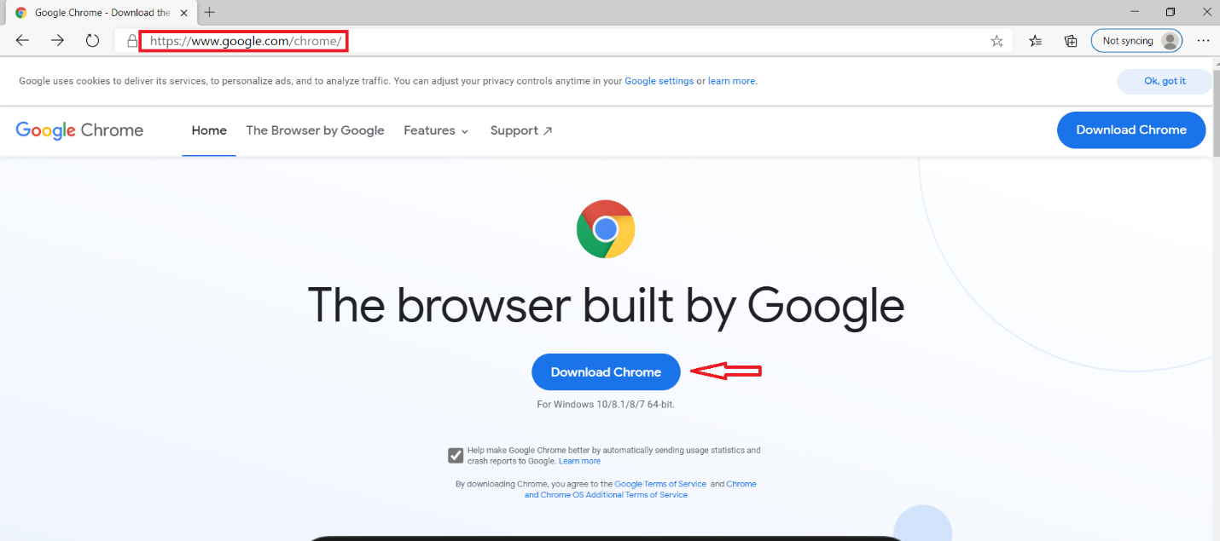

**Step 1:**  Navigate to [www.google.com/chrome/](http://www.google.com/chrome/) by typing it in to the bar at the top and hitting the ‘enter’ key on the keyboard.

**Step 2:** Click the ‘Download Chrome’ button in the middle of the screen.

**Step 3:** Follow the steps that google provides you.

After completing these steps Google Chrome should be successfully installed.

# Using Google translate

Figure 2: Navigating to Google Translate

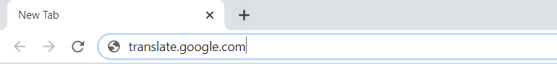

**Step 1:** Open Google Chrome

**Step 2:** Navigate to “translate.google.com”

**Note:** Unlike most websites, do not put “[www.](http://www.)” In the url.

At this point, you will now be on google translate. You should see the following page:

Figure 3: Google Translate web page

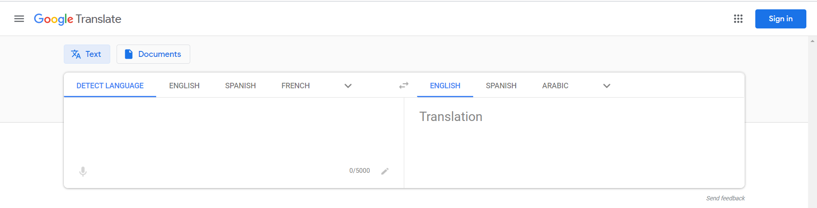

## 4.1 Navigating Google Translate

Figure 4: Navigating Google Translate

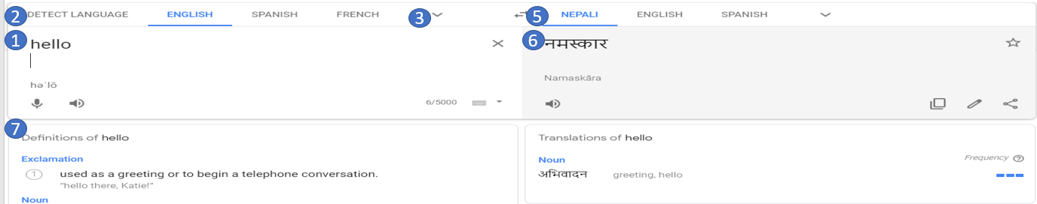

Looking at Figure 4, there is a lot going on so we will break it apart into several smaller parts.

**Step 1:**  The user can type the words they wish to translate in this box here

**Step 2:** By default, ‘Detect’ Language will be chosen and Google translate will attempt to determine what language is being used. To specify, select from the bar at #2.

**Step 3:** If the language you are looking for does not appear in the bar, click the arrow next to #3. Figure 5 should appear.

Figure 5: Selecting a Language in Google Translate

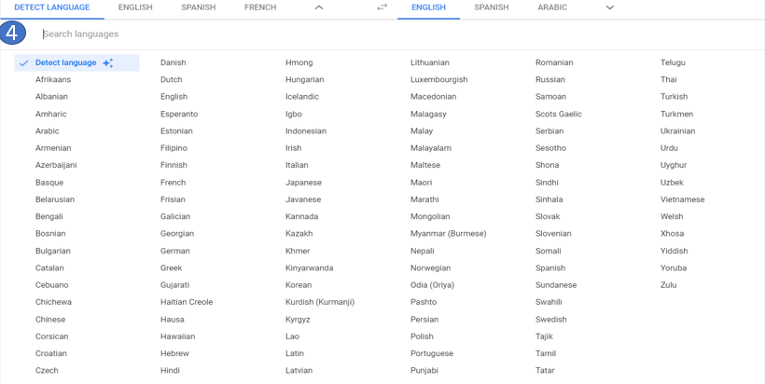

**Step 4:** Select the language you wish to translate from in the alphabetical list.

**Step 5:** Select the desired language to translate into. The same steps can be taken here from step 2-3, but with the buttons on the right side.

**Step 6:** The word or phrase will appear in the desired output language here.

**Step 7:** For simple words and phrases google will provide synonyms and definitions for the words in both languages.

Figure 6: Volume Icon for Google Translate



If the user wishes to hear the word pronounced, they can click the ‘Volume icon’ picture in figure 6 on either side of the boxes. It will pronounce it in the language that the box is printing. So, in Figure 3 if the left ‘Volume icon’ picture is clicked, it will say hello in English. If the right ‘Volume icon’ picture is clicked, it will say hello in Nepali.

# Using Google Search

Figure 7: Google Search Home Page

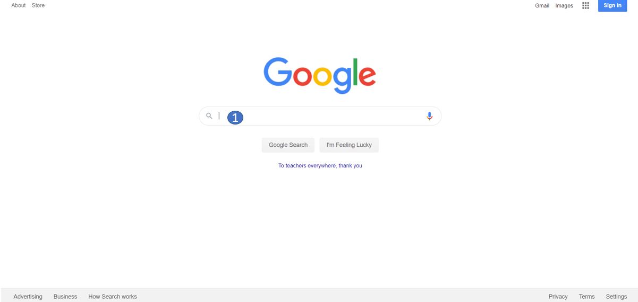

**Step 1:** Open Google Chrome

**Step 2:** Navigate to [www.google.com](http://www.google.com)

**Step 3:** In the box at Bubble 1, click the box and type the desired search terms.

**Step 4:** Click the enter button and the search will be made

## 5.1 Navigating Google Search Results

Figure 8: Navigating Google Search

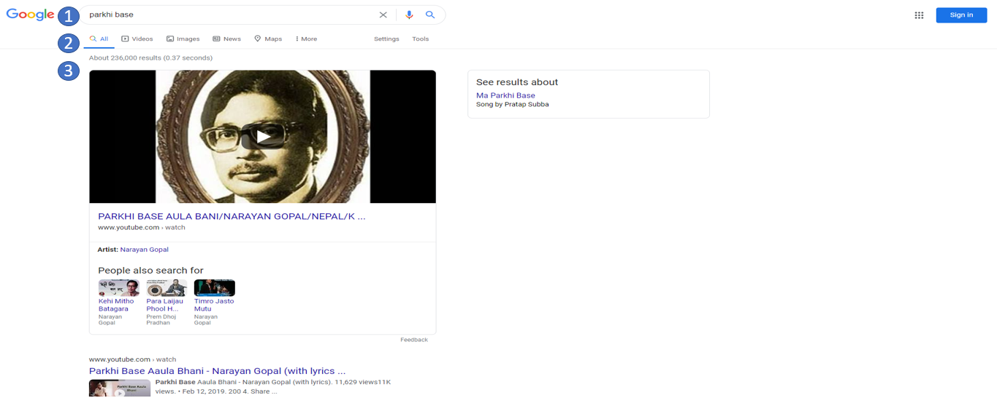

Figure 8 shows an example of a completed google search. The search bar is at Bubble #1. The search terms that were used to get this page are in there. At any time, a new search can be made by clicking in the box and typing something new, then hitting enter again. At Bubble #2 there are several different options for the search. For example, you can search by image or video if you are looking for a specific video or picture. At Bubble #3 is the first result google shows. In this case it shows a YouTube video which can be accessed by clicking anywhere on the picture, or the blue link with the video name on it.

# Using Google Scholar

Google Scholar is very similar to google search, but it is more limited in the results it shows. Google Scholar is focused on academic papers and articles. This makes it a much better tool for finding scientific or academic studies and findings. For casual questions or non-scientific questions, google search is likely the preferred tool. For educational or research purposes, google scholar is a great tool to use.

Figure 9: Google Scholar Home Page

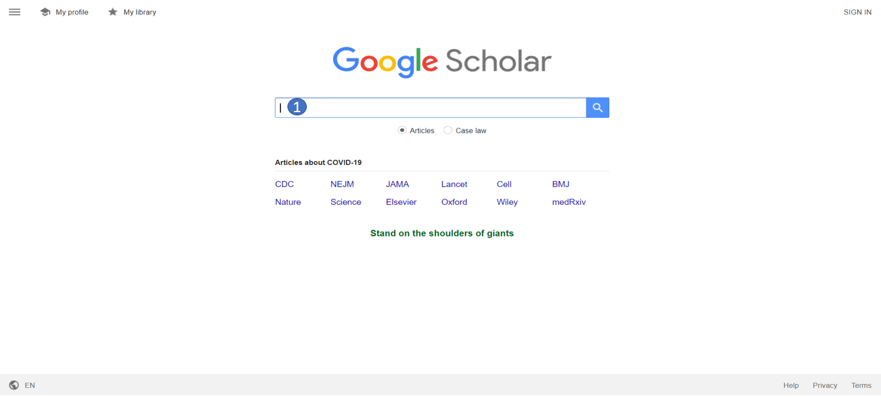

To make a search in google scholar, take the following steps:

**Step 1:** Open Google Chrome

**Step 2:** Navigate to scholar.google.com

**Note:** Do not put “www.” before scholar

**Step 3:** In the search bar at bubble #1, enter the desired search terms

Figure 10: Navigating Google Scholar

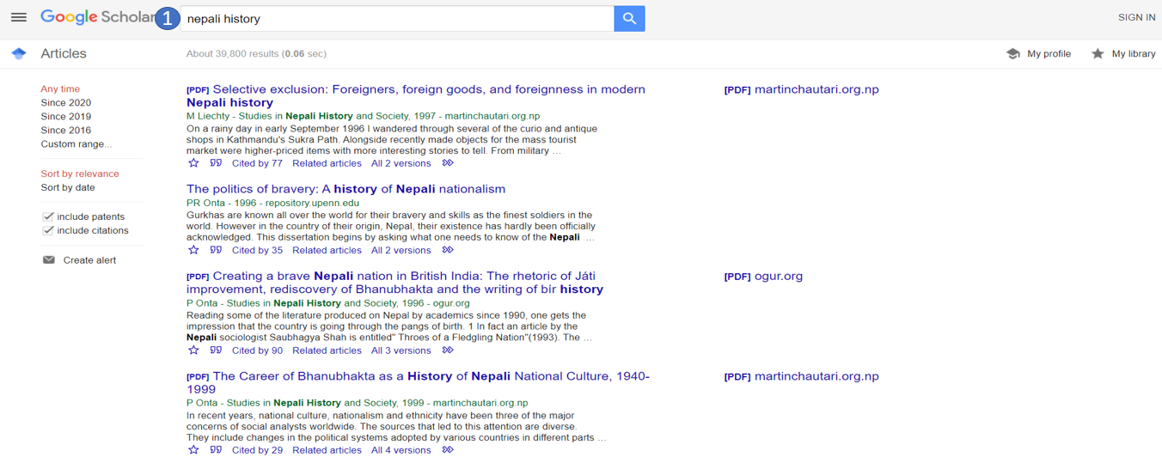

## 6.1 Navigating Google Scholar Search Results

Just like normal google search, the search bar will be at the top of the screen at Bubble #1 after making a search. The following few sections will go through how to do several actions in google scholar.

## 6.2 Saving to ‘My Library’

Figure 11: Saving to Library part 1

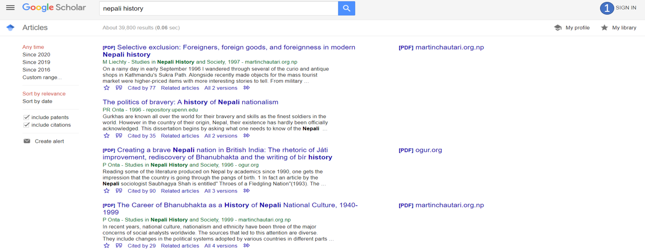

**Step 1:** If there is a ‘sign in’ option at Bubble #1, click that and follow the steps provided by google to either sign in or create an account.

Figure 12: Saving to Library Part 2

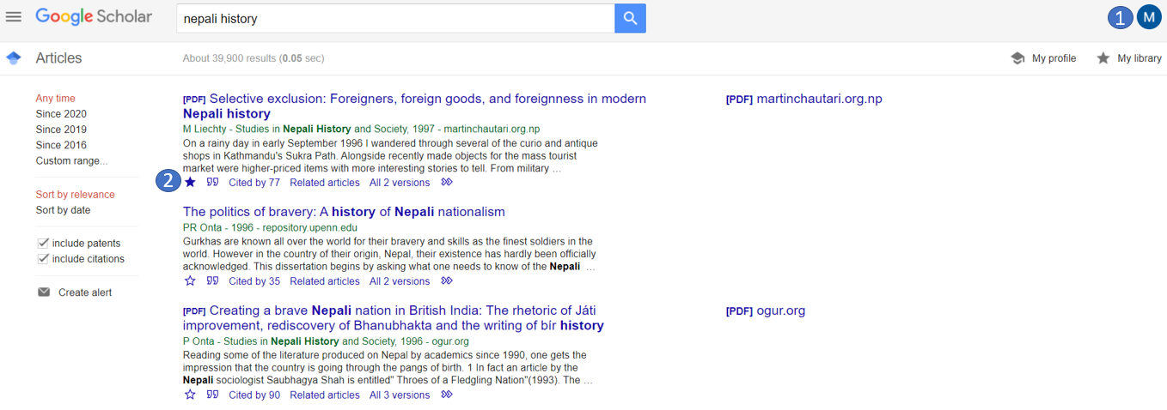

**Step 2:** You should now see a Bubble with a letter next to Bubble #1.

**Step 3:** To Save an article to ‘My Library’ click the star next to Bubble #2. If it is saved, it will be filled in as it is next to Bubble #2. If the star is not filled in the article is not saved.

## 6.3 Viewing ‘My Library’

Figure 13: Navigating to 'My Library'

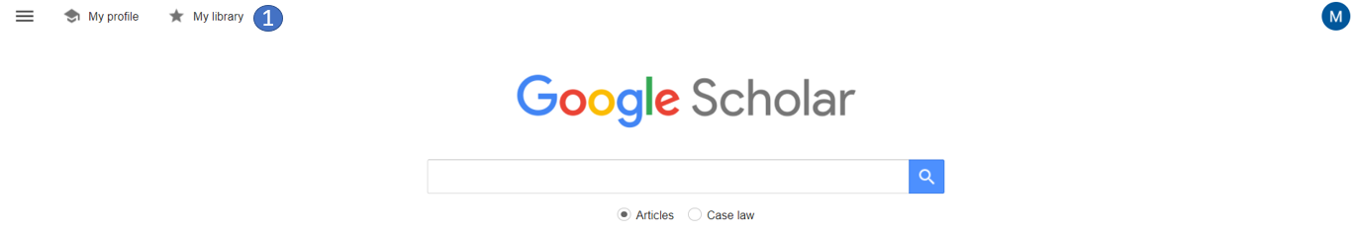

**Step 1:** Navigate to scholar.google.com

**Step 2:** Sign in if not already signed in

**Step 3:** Click the ‘My Library’ text at Bubble #1

Figure 14: Navigating 'My Library'

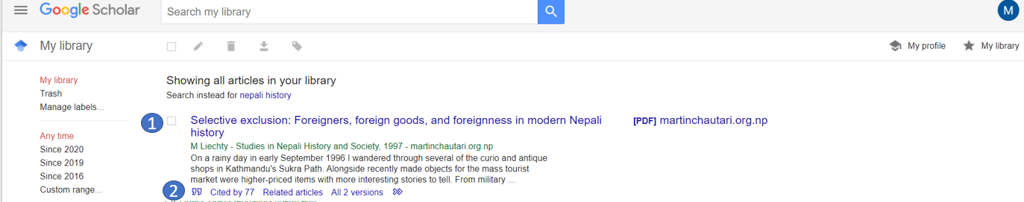

**Step 4:** You will be taken to a page that looks like figure 14. In here there is the article saved from figure 12. At Bubble #1 you can see the name.

**Step 5:** If you wish to cite the article, click the ‘”’ next to Bubble #2. Several options will appear, and the user can select whichever citation option is needed for their use.